QUICK GUIDE ON COMPLETING A
PERSONAL DEVELOPMENT REVIEW (PDR) FORM FOR REVIEWEES

For more detailed guidance on completing your PDR please read the relevant sections of the PDR Guidance.

Personal Development Review Process
The line manager (Reviewer) sets a date for the PDR meeting between January-March to review the previous annual year.
The employee (Reviewee) generates their PDR form via the Review Lifecycle found under the Performance tab in MyWorkplace by clicking on the Generate button. The Reviewee completes the Personal Development Review (part 1) section in the PDR form.
The Reviewee reviews each of their objectives and rates their status. Objectives can be added at the beginning of this process and new objectives added/amended throughout the year.
Once they have completed the Personal Development Review section (part 1) in the PDR form they need to save it and submit. which will inform the Reviewer.
Personal Development Review meeting is held to discuss progress over the past year, achievements, workload, career aspirations, professional and personal development. New objectives for the coming year are also agreed.

Reviewer completes the Summary Comments from the Reviewer in the PDR form following PDR meeting, based on the review meeting discussions. The Reviewer sets this as complete in the Lifecycle and the Reviewee is informed.
The Reviewee agrees the Summary Comments from the Reviewer. If they wish to discuss further they should contact their Reviewer. The Reviewee completes the Summary Comments from the Reviewee in the PDR form following PR meeting, based on the review meeting discussions. The Reviewee sets this as complete in the Lifecycle and the Reviewer is informed.
The Reviewer checks Summary Comments from the Reviewee and the PDR form is now complete.
The Reviewer sets form as complete in the Lifecycle.
Reviewee adds new objectives discussed at PDR meeting as part of the next PDR cycle.

- Review lifecycles
PDR forms operate using what are called “lifecycles”. There are five stages to the Lifecycle:
  - The Reviewee generates the PDR form by accessing the Review Lifecycle in MyWorkplace and clicking the “generate” button.
  - The Reviewee completes the Personal Development Review section of the form (part 1). They press “submit” once completed.
  - The Reviewer adds their summary comments. They then update the Lifecycle to confirm this.
  - The Reviewee adds their summary comments. They then update the Lifecycle to confirm this.
  - The Reviewer marks the PDR as complete.
The PDR form and the lifecycle are shown differently in MyWorkplace. Once the Reviewer or Reviewee completes their action, i.e. adds their comments, they should go into the Lifecycle and click “complete”. This will trigger an email to the other party to inform them.
For the Reviewee, the lifecycles can be found above Review forms.

Generating your PDR form
To generate the PDR form, the Reviewee should navigate to the “Performance” section of MyWorkplace and click on the Review Lifecycle.
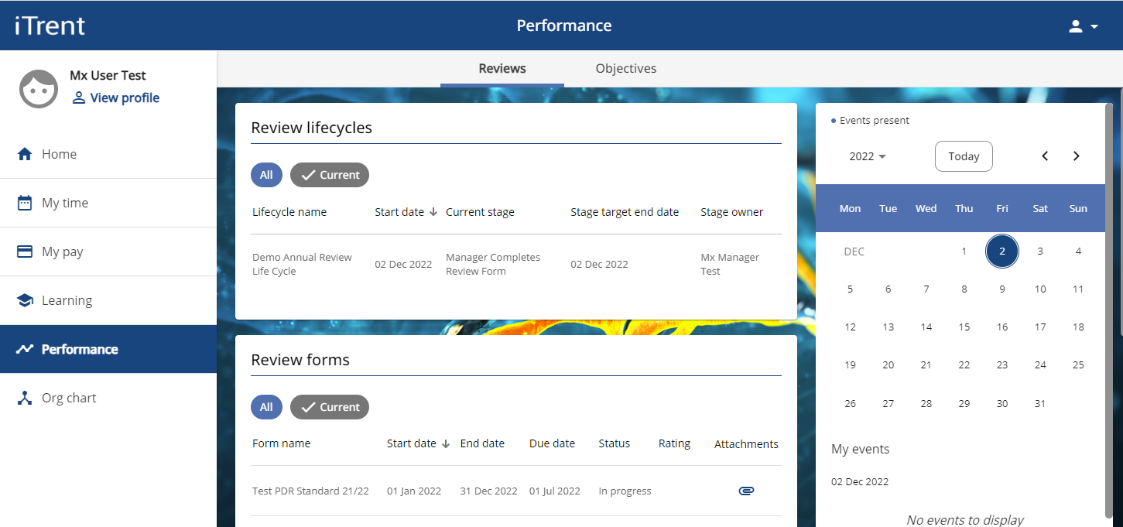

There will be a “Generate” button under the first part of the Lifecycle. Click this to generate the PDR form.
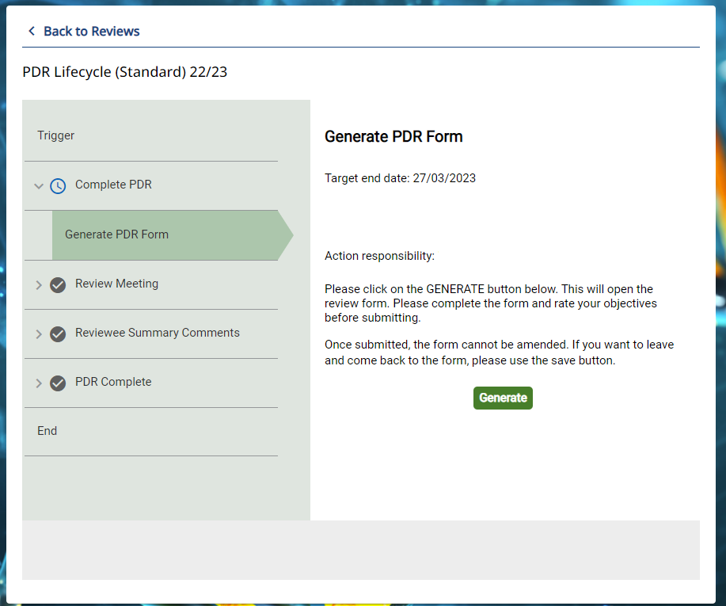

The Reviewee should complete part 1 of the form (Personal Development Review). To access part 1, click the words “Personal Development Review” to the left as seen in the below screenshot.
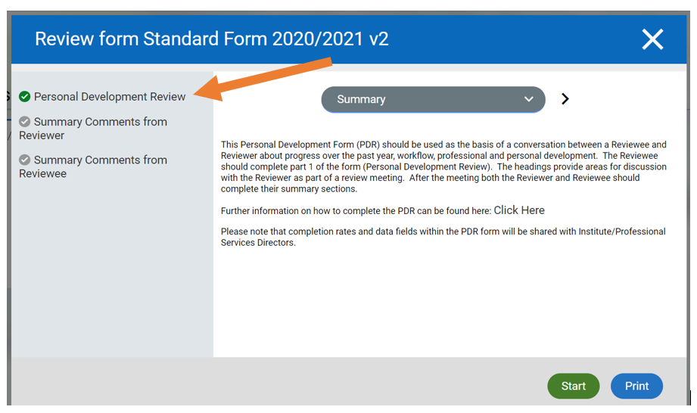

Saving and submitting the PDR Form
The PDR form should be saved regularly, particularly before moving to a different page, otherwise additions will be lost. In addition, the form will be “timed out” after 3 hours, therefore it is important to make sure that the PDR is saved within this timeframe.
Unfortunately, the PDR does not autosave due to system constraints imposed by the external provider. The PDR should therefore be saved at regular intervals. Do not paste text in from Word because if it contains formatting that MyWorkplace, it can cause the form not to save. (A solution is to save the Word document in plain text or use Notepad).
When the Reviewee has completed the Personal Development Review section of the form (part 1). They should press “submit”. This will trigger an email to your line manager (Reviewer) and you will then have your planned PDR meeting.

Setting objectives
Both the Reviewer and Reviewee can set and amend objectives. This can be done via the PDR form itself or in MyWorkplace - under “Performance / Objectives / +Add objectives. Objectives can be added or amended throughout the year as well as at the time of the PDR meeting.
Objectives should be SMART – ie Specific, Measurable, Achievable, Realistic and Timebound (ie have a completion date).

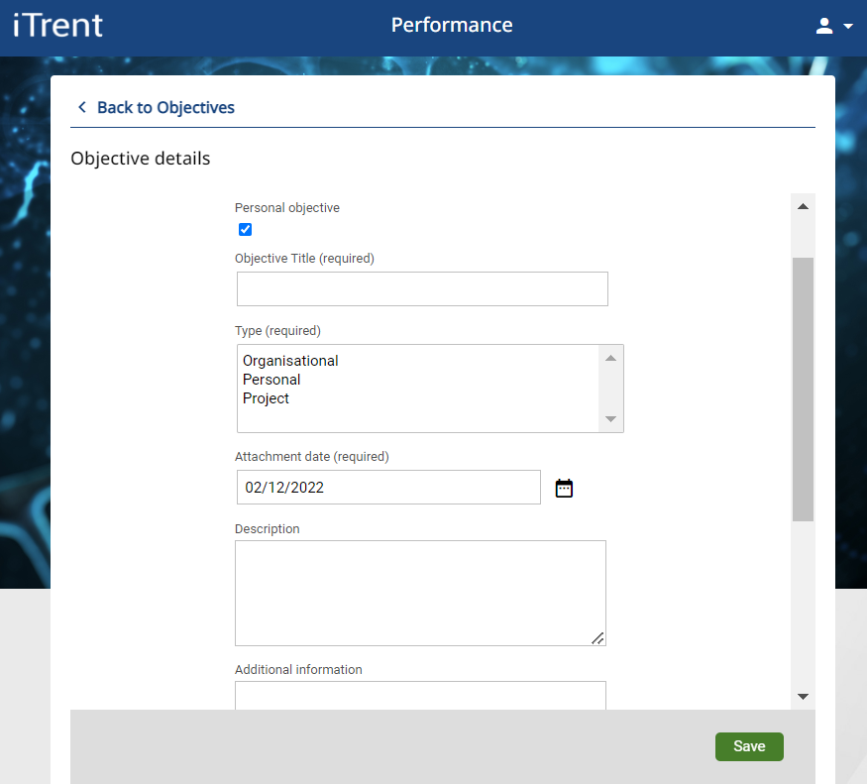

- NB when setting an objective, the “Personal Objective” box must be ticked.
- Provide a name for the objective under “Objective Title”. This is a mandatory field and must be completed but is restricted to 80 characters.
- The attachment date will automatically default to the date the objective was added. There is no need to change this unless either the Reviewer or Reviewee specifically wish to.
- Add a description of what the objective covers, for example the nature of the objective, how it will be achieved and how it will be measured.
- Add any additional information, if required, for example objective milestones.
- As the name suggests, the start date is the date the objective became effective. This can be left blank if required.
- Completion date should reflect the expected date of completion of the objective. This date can be amended over time should the objective be completed sooner or later than anticipated. The date can be left blank if the completion date is not yet known.
- Objective rating method – there is no need to change this from UNISG.
- A dropdown box is offered to provide a rating for objectives, choose the appropriate rating, which the Reviewee should agree with their Reviewer as part of their discussions.

