How to view Amounts on a PO
Go to the Goods Receipts screen | Amount definitions
Access Agresso and navigate to the Goods Receipt screen  - Procurement  2  - Purchase orders  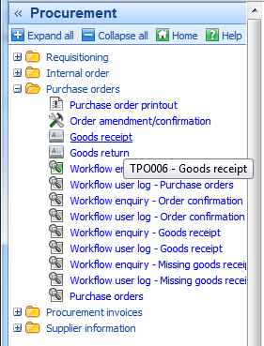  - Goods receipt  - Goods Receipt screen  1  3  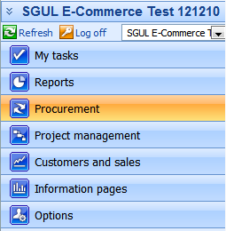  4  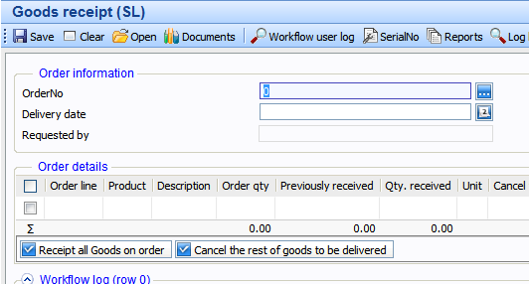  Open up the Purchase Order Info dialog box  - Enter the purchase order number into the Order No. field and click on the field help button  - Once your Purchase order no. is loaded click on the order no.  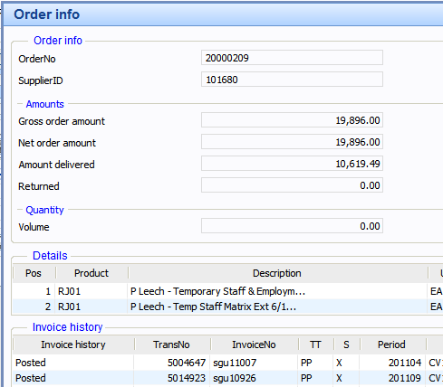  - The Purchase order info dialog box appears with the amounts section  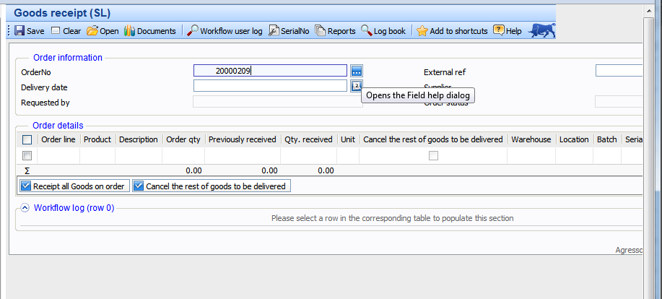  3  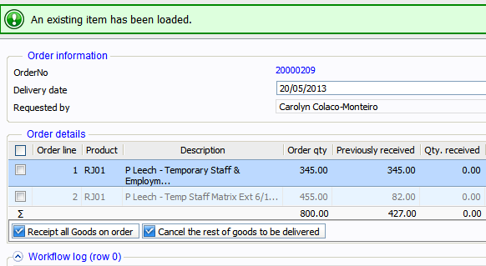  2  1 | Net amount (value of goods/services originally ordered)  Amount delivered (Goods delivered and receipted)  Returned (Negative receipting or goods returned to supplier)  To Invoice (Total amount to be invoiced)  Registered invoices (Invoices received by Accounts Payable (AP))  Posted (Processed to be paid)

