How to check if an invoice has been paid
Supplier Enquiry
Open Agresso and select the Reports module> Global Reports>Requisitioners Reports> Supplier Enquiry
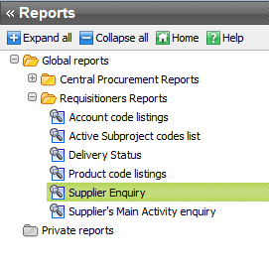
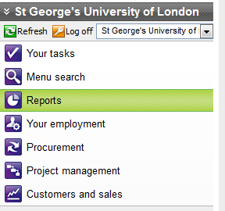

Enter the invoice number into the InvoiceNo field and then click on the Search button.

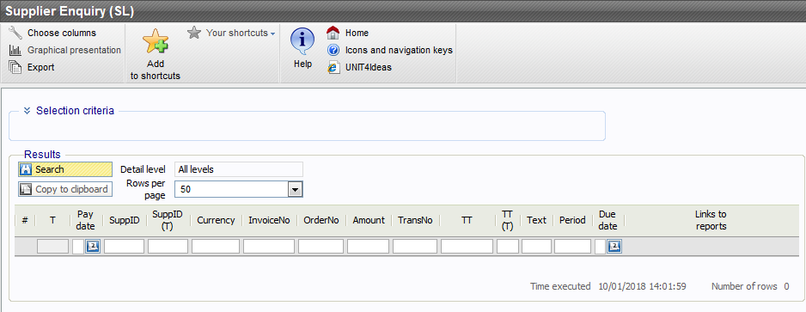

Results will only appear if Accounts Payable have received and registered the invoice. You may have to arrange for another copy to be sent to them.

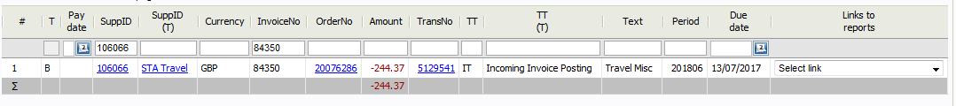
Check the Paydate column to find out when the invoice was paid.
Click on the TransNo to see a scan of the registered supplier’s invoice.
If there is no date then check the T column for the status of the
invoice.

A: Task alert
B: Approved and waiting for payment
C: Has been paid

