Go to the Purchase orders folder | Screens that you can print from
Access Agresso and navigate to the Purchase orders folder  - Procurement  - Purchase orders  - You can pick any one of the Purchase order screens to print from  - Click on the Goods Receipt screen  2  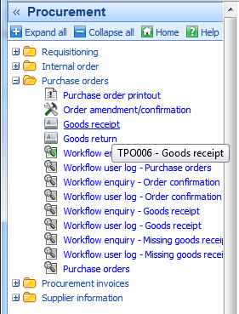  1  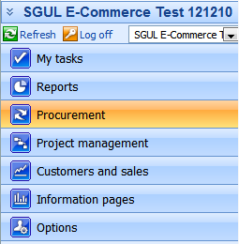  3  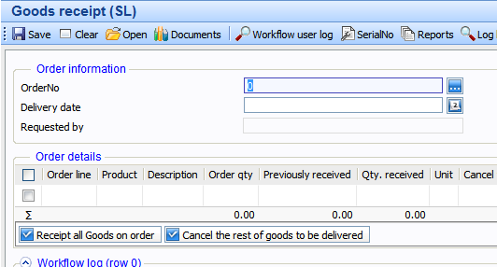  4  Load the Purchase Order and print it out  - Enter the purchase order number into the Order No. field and click on the field help button  - Once your Purchase order no. is loaded click on Document button from the menu  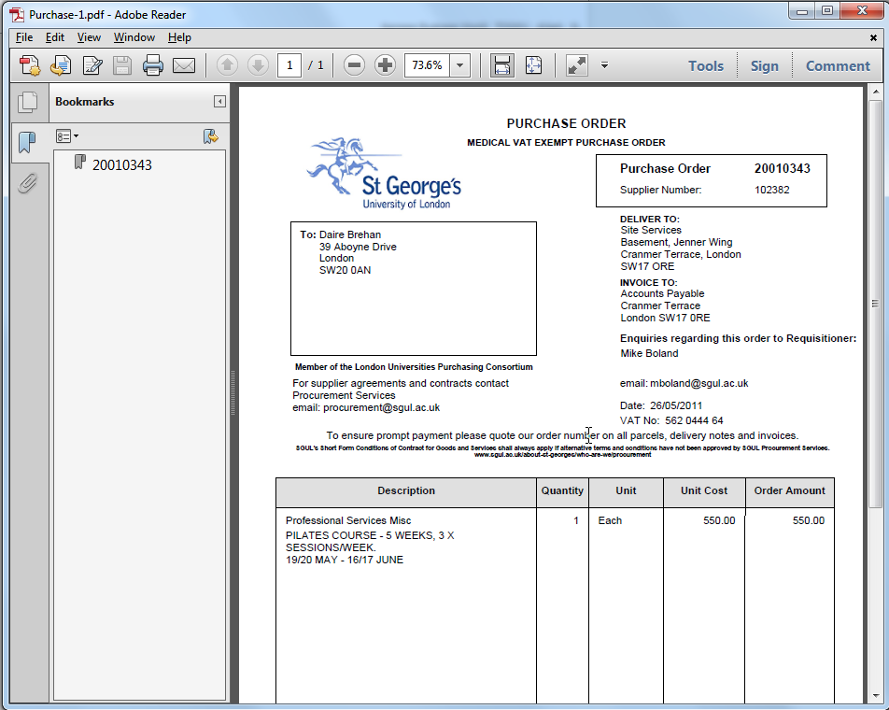  - Click on the Purchase order link from the Documents box to open the PO in the PDF reader  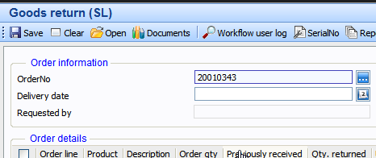  1  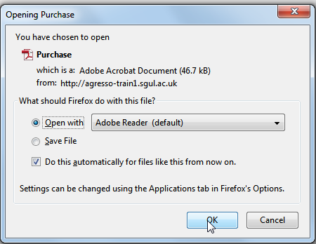  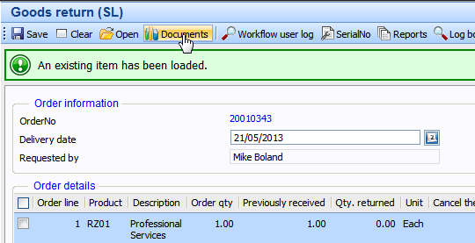  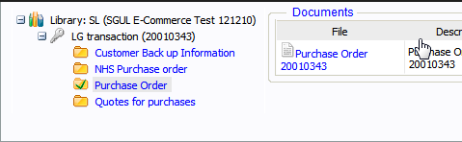  3  2  2 | Order amendment/confirmation  Goods Receipt  Goods Return  Open up (PDF) and print out Purchase Order.

