Inline search | Copy an old requisition
Access Agresso and navigate to the Purchase orders folder  - Procurement  - Requisitions> Requisitions standard  - Search using the supplier name  - Or the supplier code by typing into the inline search and a drop down menu appears with results  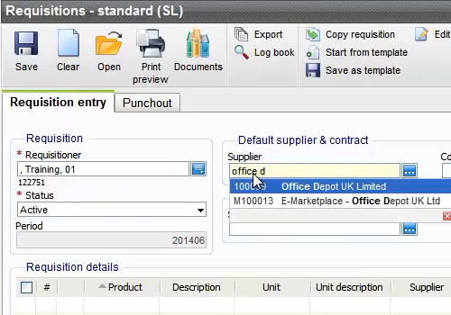  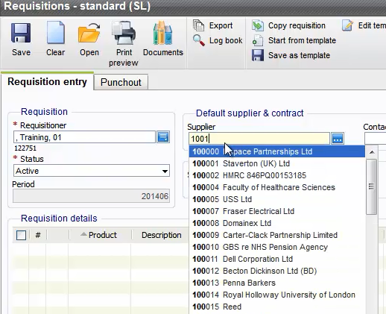  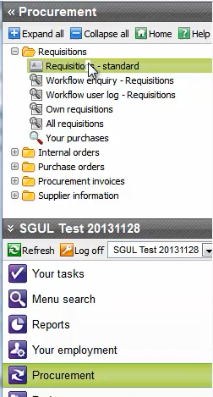  3  2  1  4 | - Procurement  - Requisitions  - Own requisitions  2  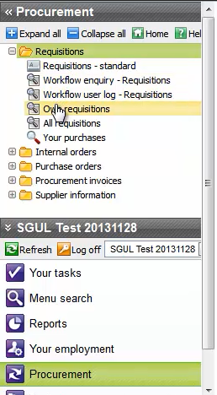  1  3  - Select requisition and load it  4  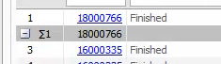  - Click onCopy requisition from the menu  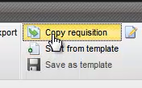  5  - Make your relevant changes to the requisition detail line and then save  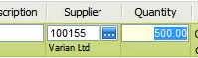  6  - You will be taken through the posting cycle where a new requisition number will be assigned  Open up (PDF) and print out Purchase Order.

