The Purchase Order Process
Overview of the PO Process
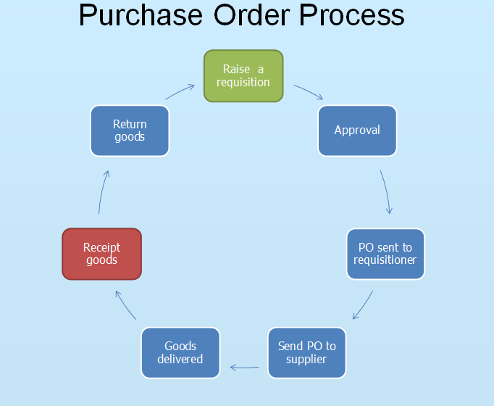  7  6  5  4  3  2  1  - Raise a requisition – Anyone who has an Agresso account can raise a requisition. If you are an approver and you raise one then a financial approver will be added to the process  - Approval - Once the requisition has been approved, it is entered into a batch where every 15 minutes they are turned into Purchase orders.  - PO sent to requisitioner – An email with an attached purchase order is sent from the system to the requisitioner.  - Send PO to supplier – The requisitioner can forward the email to the supplier or print it out and fax it or send via the royal mail.  - Goods delivered – The Supplier picks, packs and delivers the goods to site services who then delivers them to your office  - Receipt goods – Anyone with an Agresso account can receipt the goods when they arrive. Most deliveries will have a delivery note attached that will have a PO number on it. Accounts payable will not pay invoices from the supplier until services or goods have been receipted.  - Return goods – Sometimes services or goods are no good and you have the need to return the item. Only use the Goods returns screen if you have already receipted the item/ service. | 