Create a Requisition in Self Service using Punch-out | Filter/Sort Page
Login to FRIS. Select Self Service - Procurement – Requisitioning – Requisition Standard  - Punchout gives you access to 29 suppliers including; Office Depot, Banner Business Services Ltd, Misco & Sigma  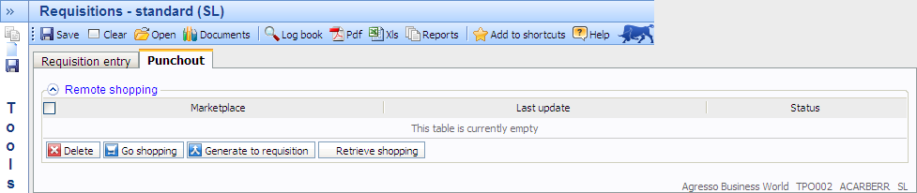  Whilst using punch-out you will need to follow a different order to standard requisitioning.  - Enter Subproject code before you select Go Shopping. If unknown use Field help to search 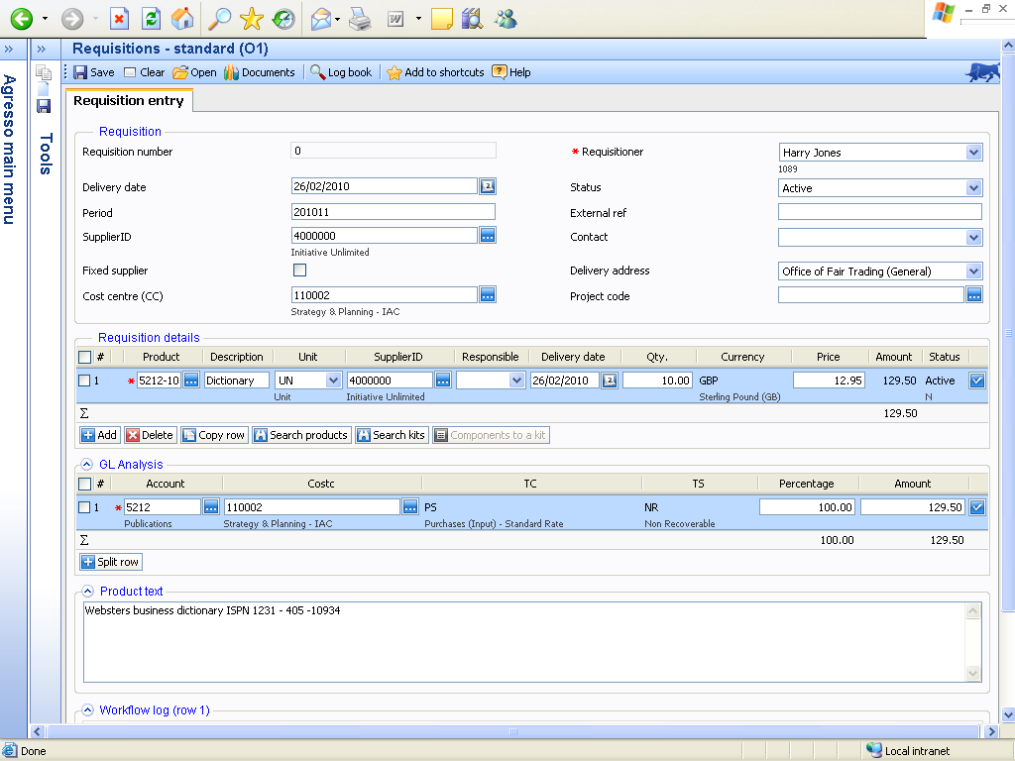  NOTE: Requisition details lines will be populated once you have completed punch-out to e-marketplace.  - Select Punchout tab to view soft button to open Science Warehouse shopping site.  - Once ready to view the shopping site click Go Shopping. It will automatically open a new browser window.  You can view:  - Recent orders  - Saved baskets  - Favourite products  - Quotes  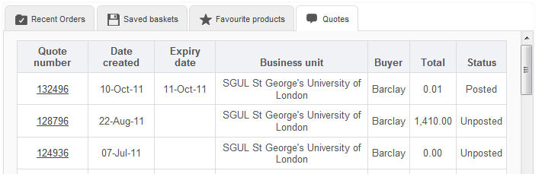 | 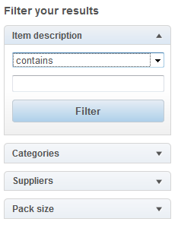  Filter on keywords, categories, suppliers or pack size.  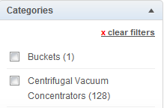  Put a tick next to the items you wish to filter on. Click on the clear filters link to remove filters.
Searching for a product
You can search for products based on the following parameters: keywords or generic terms e.g. needle, Catalogue number, Part number, Brand name. Supplier e.g. Invitrogen, Required sizes/attributes e.g. 100gsm or Product applications
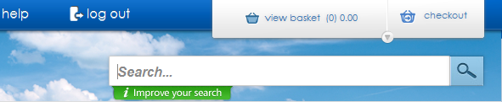
To search enter the applicable parameter e.g. pens and either click Enter on keyboard or Search on the web page.
Create a saved basket |  | Compare products
      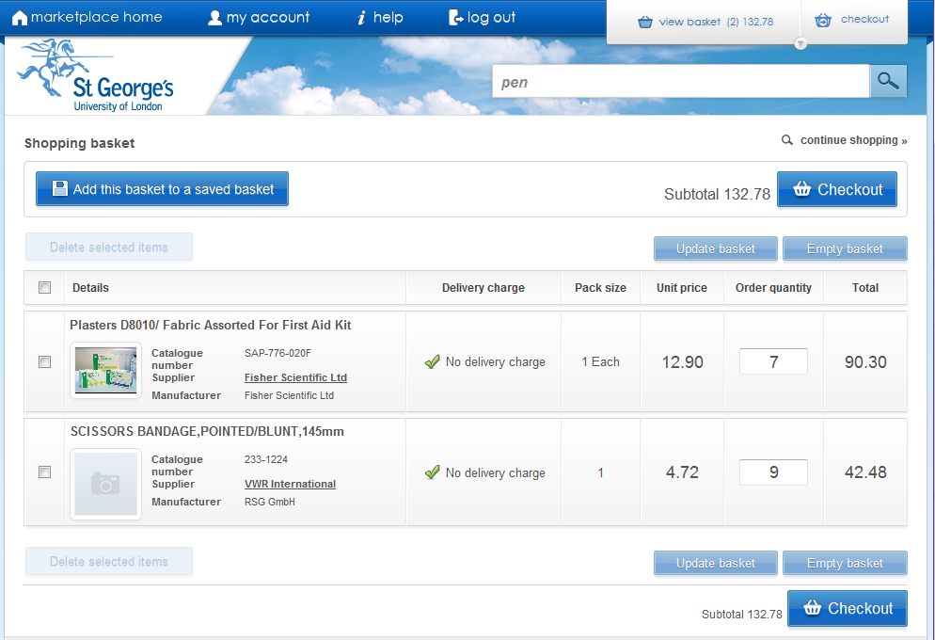  Once you have selected the items you want to add to your basket you can create a saved basket for future use. Once items have been add to your current basket, go to 1. View Shopping Basket and click 2. Add this basket to a saved basket.  1.  21.  31.  1.  21.  Enter a memorable name and click the Create new saved basket button. All saved baskets you create will be visible from your Marketplace home page.  Click the name of the basket to select. You will be taken to the applicable shopping basket where you will be able to edit quantities and also delete and unwanted lines. Lines that are deleted will remain in the saved basket unless Update basket is selected. Click Add to Basket once you are ready to use your selection. Select 3. Checkout to generate a requisition in FRIS Self Service. | 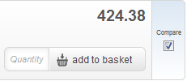  Select the tick box of all the items you want to compare.  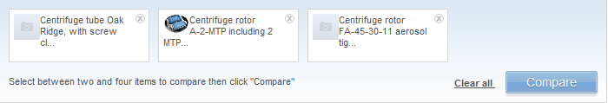  Click Compare at the top of the page to view side by side. This will open on a new page.
 | Favourites
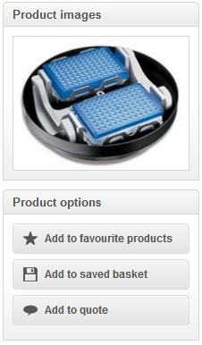Click Product details. Click Add to Favourites.

Click Marketplace Home to see the dashboard →Select Favourites to view.
Request for Quotation
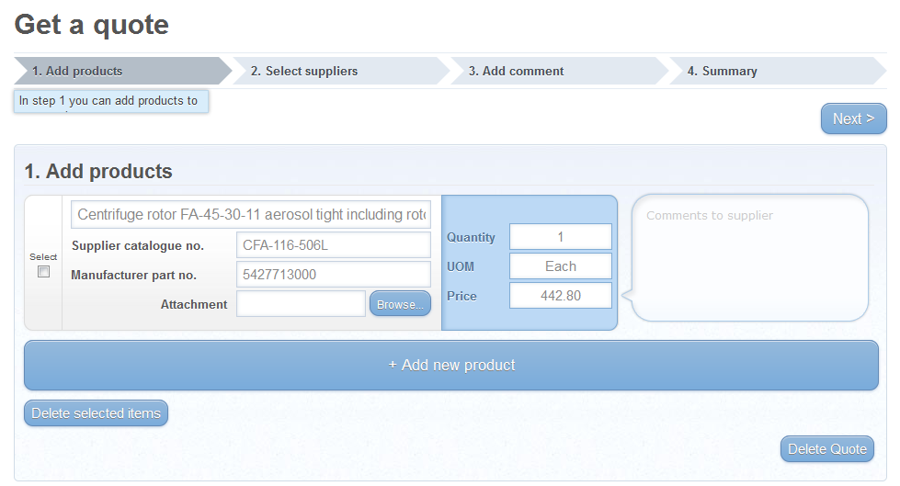
If you need to get a quote for an order e.g. for a large quantity you can complete a Quote screen on the SWL site.
- Firstly select the product you want a quote for and drill down to the product details screen.
- Enter quantity, and select Add to quote button
- On new screen you have the option to Start a new quote or update an existing
- Select from list of all suppliers the suppliers
- Add a comment for the supplier
- Edit summary and enter closing date for quote submission in Quote Expires
- Send quote / Save Quote / Delete Quote / Print quote.

The status of your quote will change in your homepage dashboard, when a response is received from a supplier to your quote as it is highlighted green. When you go into it (click on the Quote number) you will see what price they have replied with. If you are happy with the new price you can "Add All to PR" to turn the products and prices into a purchase requisition for submission in the normal way.

Retrieve Shopping & Generate Requisition
To extract your order from SWL site, in FRIS Self Service, click Retrieve Shopping on Punchout tab. A line(s) will appear with Marketplace name and date of update.
Click the line(s) you want to create a requisition for Click the line(s) you want to create a requisition for and click Generate to Requisition.
The lines will appear on the Requisition Entry tab as usual.
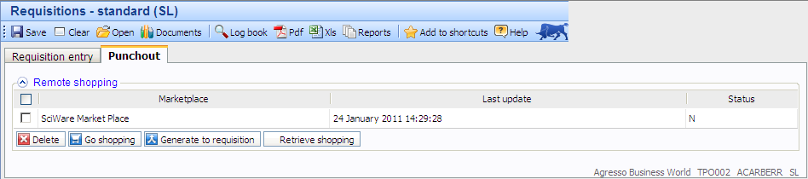Follow usual requisition process thereafter to enter workflow for approval and also to generate Purchase Order. A copy will also be available in SWL website under Recent orders on the Homepage dashboard.
