The Accounts Payable Process
Getting familiar with the Accounts Payable process can and will save you time when purchasing goods and services at St George’s. It can eradicate the toing and froing between accounts payable and suppliers, when trying to pay an invoice.

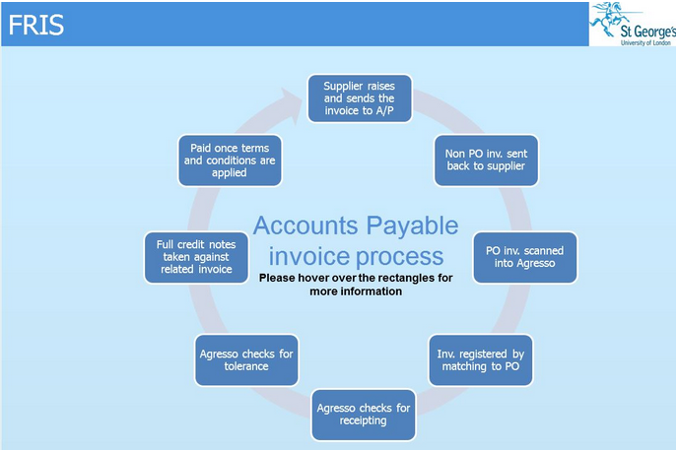
3
[[[
4
[[[1
5
[1
[[[
6
[[
7
[[
8
[[
1
2
- Supplier raises and sends the invoice to Accounts Payable – Purchase orders are sent to the supplier before they raise an invoice. Accounts Payable (AP) sort the invoices into two categories (Invoices without a PO no. on it and invoices with a PO no. on it.

- Non PO invoice sent back to the supplier – Accounts Payable will not accept Purchase Order numbers written onto the supplier invoice retrospectively.

- PO invoices are scanned into Agresso – The scanned invoices are linked to the transaction no. and can be seen in Agresso tasks and budget holder’s reports.

- Invoice is registered onto Agresso by matching invoice to a PO – AP enters the invoice number and amount requested from the supplier. A code amendment task is sent out to the requisitioner / budget holder, asking for the Account code, Subproject code and Tax code, if AP cannot match an invoice to a PO number.

- Agresso checks for receipting – A missing goods task alert is sent out to the requisitioners if the items being paid for has not been receipted.

- Agresso checks for tolerance – A tolerance task is sent out to the budget holder if the amount of the invoice is for more than the amount on the PO. This happens when delivery charges are not included or the wrong tax code is used.

- Full credit notes taken against related invoices – part credit notes are sent to the requisitioner via a code amendment task. Requisitioners are required to supply the Account code, Subproject code and Tax code.

- Paid once terms and conditions are applied – A weekly batch payment of invoices is made on a Tuesday morning. Invoices are only paid once agreed terms and conditions are satisfied.

