

ESS- MyWorkplace
Payslip Guidance

Introduction
From April 2018 the HR/Payroll system used at SGUL is iTrent provided by MHR. The Employee Self Service (ESS) access will be known as MyWorkplace.
Payslips and P60s will be viewable on screen, available to be downloaded as a pdf or you can set up your preferences to have your payslip emailed to you when available each pay day.

The following guide will explain and show you how to do each of these options.

Access the System
The system access has been designed at SGUL using the single sign on method, which means your network user name will be used to access ESS.
The following link will take you to the login page
My Workplace
There is also an icon on your desktop 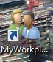
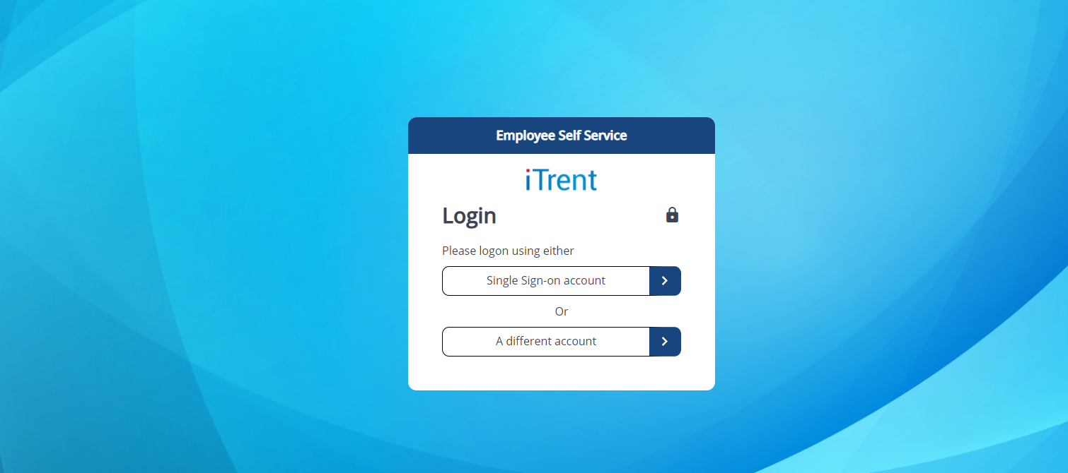
Click on Single Sign-on account, if not automatically logged in.
Once your user name has been validated against the network, you will be presented to the homepage of MyWorkplace.
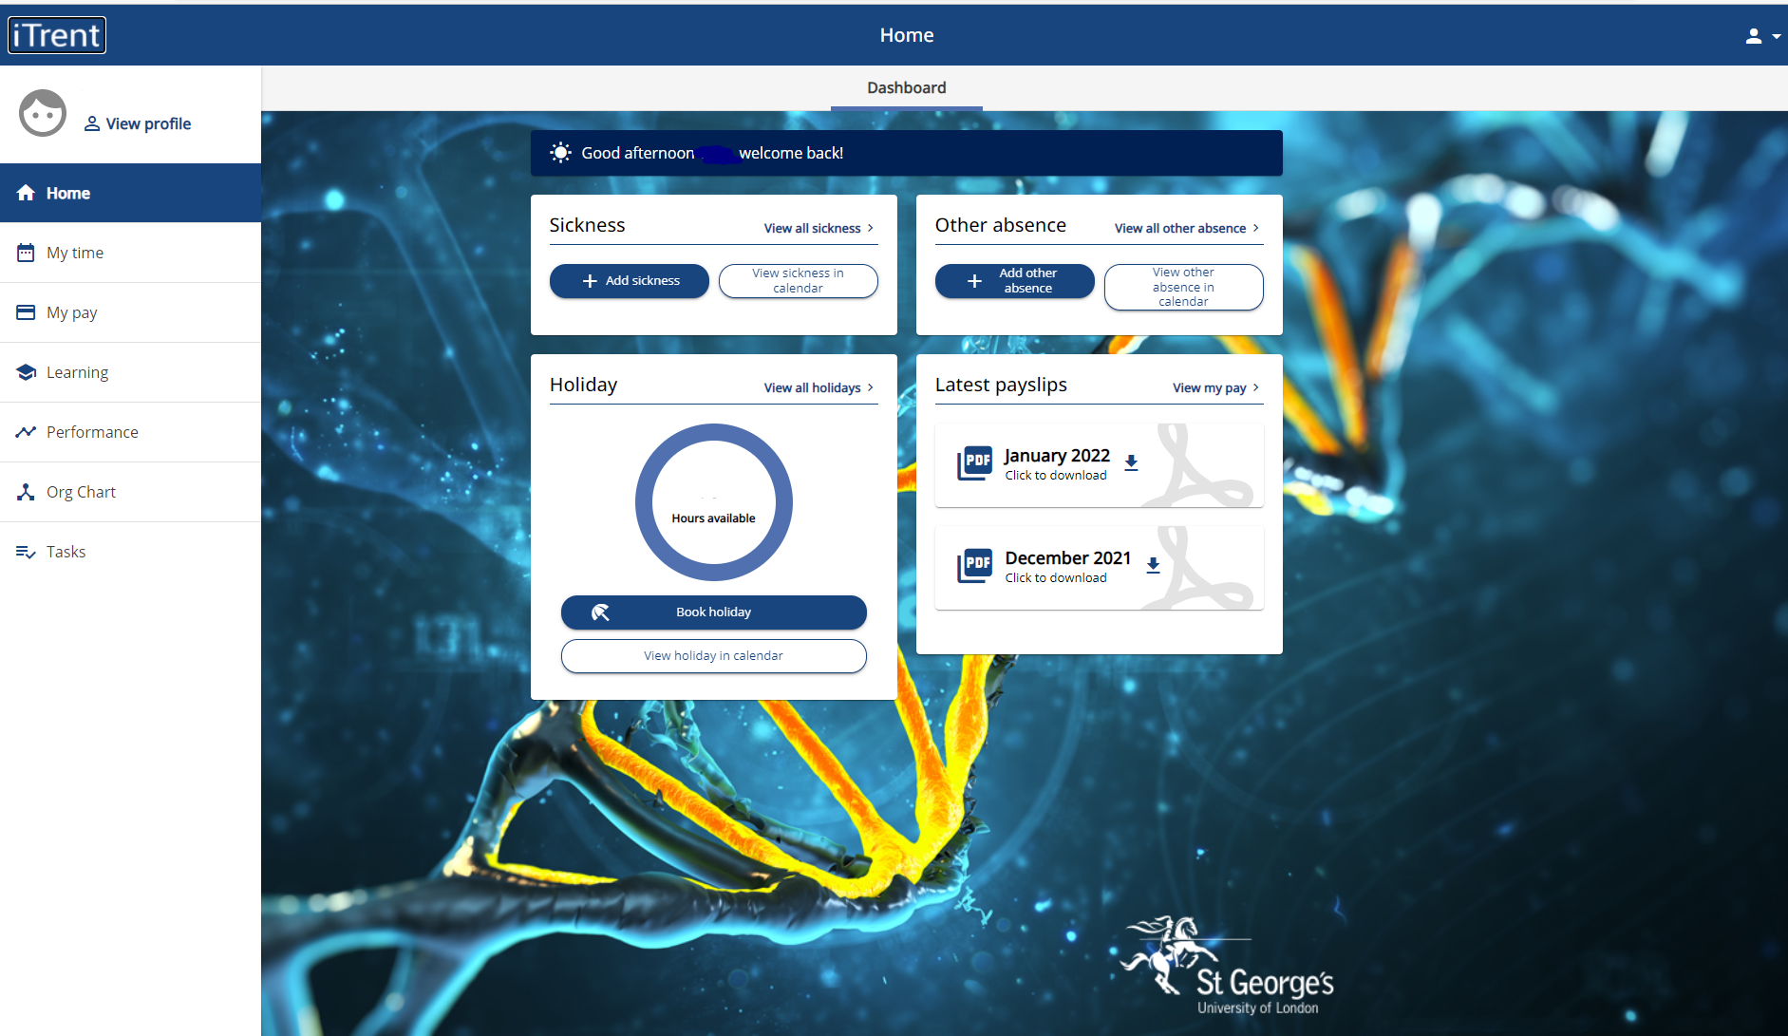

On this screen you can click on “My Pay” which can be found on the left
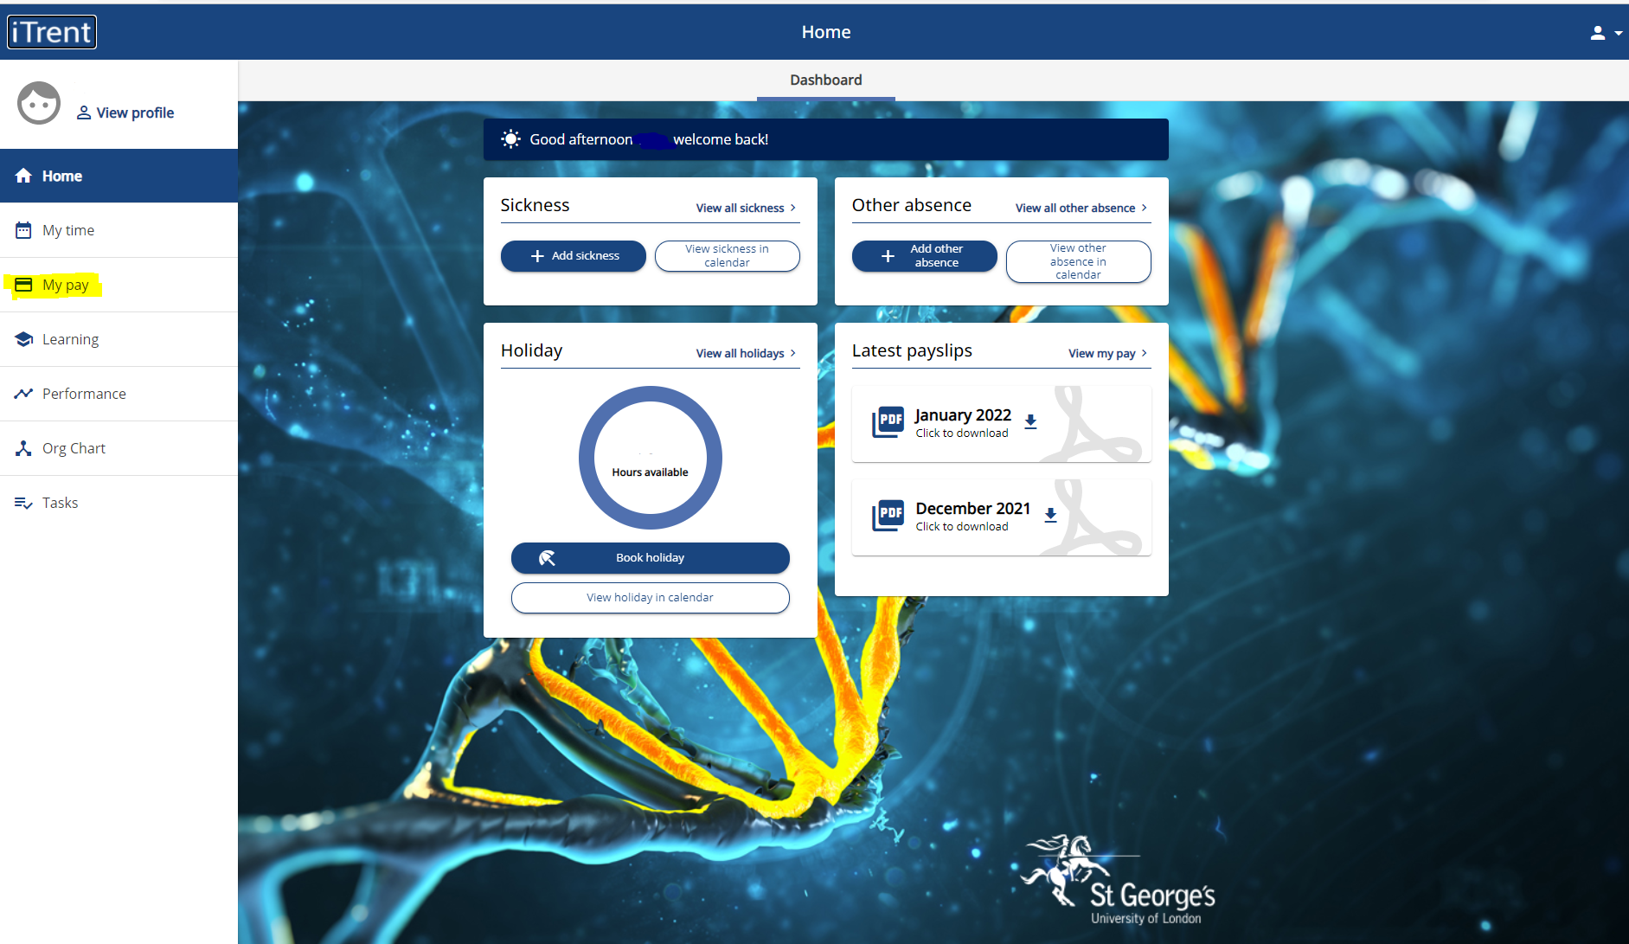
Or on the View my pay on the centre of your screen
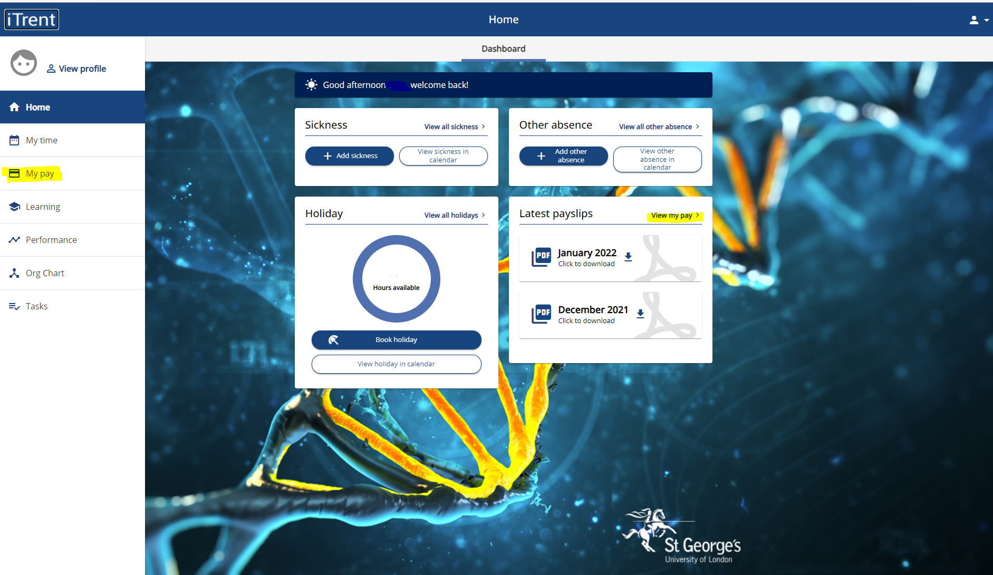

Both places will take you to your payslip and P60 screen
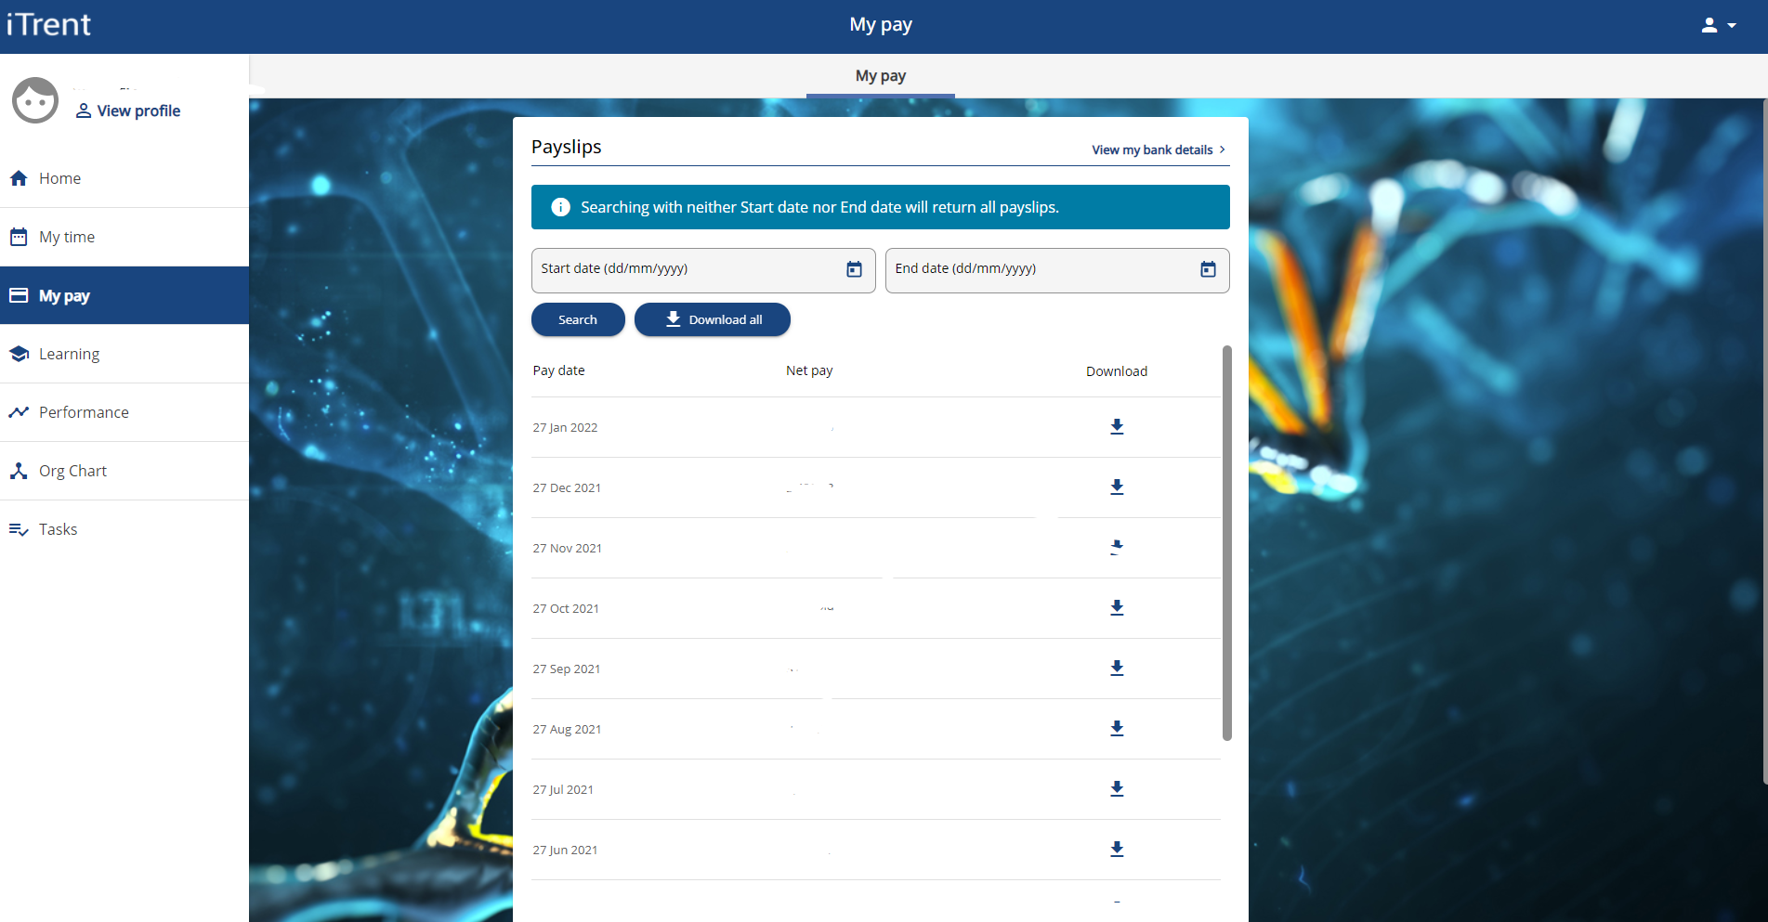
And scroll down to P60 information
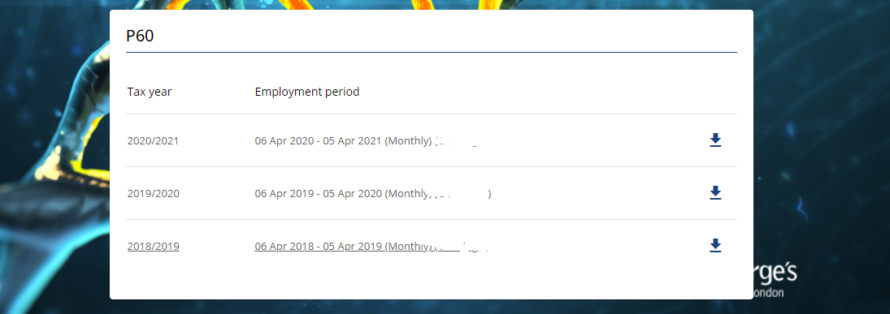
To view and download an individual period.
Click on the relevant month under tax year
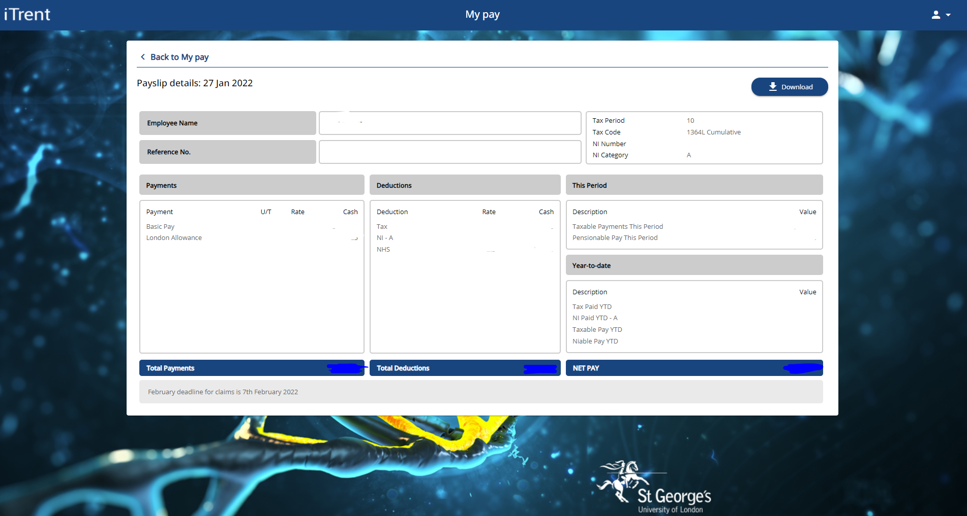

Then click on download or click on the arrow at the right hand side. You can then save of print the pdf version of the payslip.
If you wish to print/save multiple periods then the system has been set that you can do this without going into each period.

To access this functionality, click on the download all or enter a period range at the top
Enter the start and end dates, click on search and click on confirm
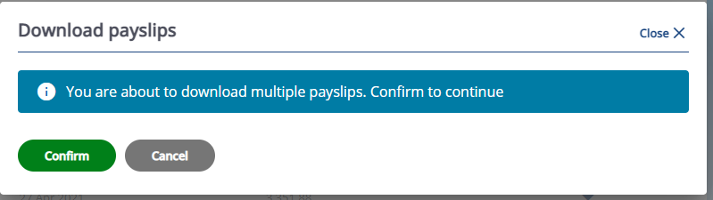
All payslips that fall into this range will be available to download
Click on download and the payslips within the range will be downloaded and you will have the option of either saving the pdf document or printing the pdf document.

Set up to receive payslips and P60s via email.
Within the My Workplace functionality, you are able to set up for your payslips to be emailed to you each pay period to an email address of your choice. The payslips will be delivered password protected and your password can be of your choice and not linked to the network like your standard access.

From the home screen
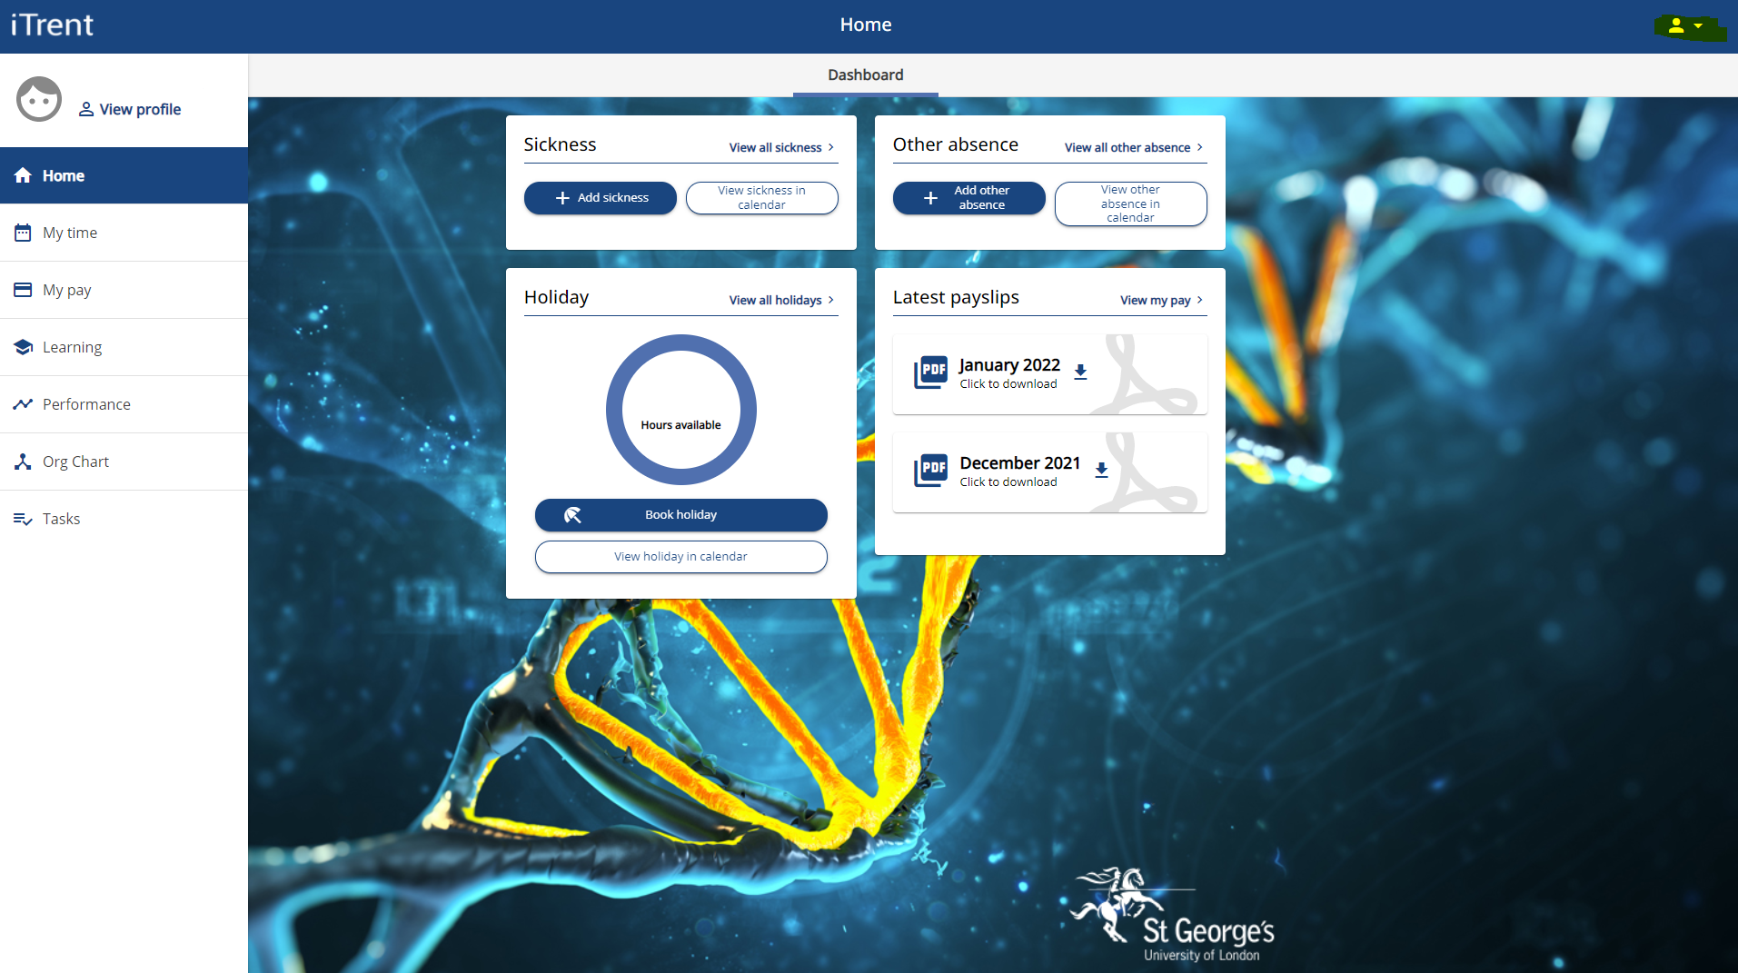
Click on the drop down arrow at the side of the face icon which is on the right hand side of the top task bar
Click on Settings and then E-form preferences
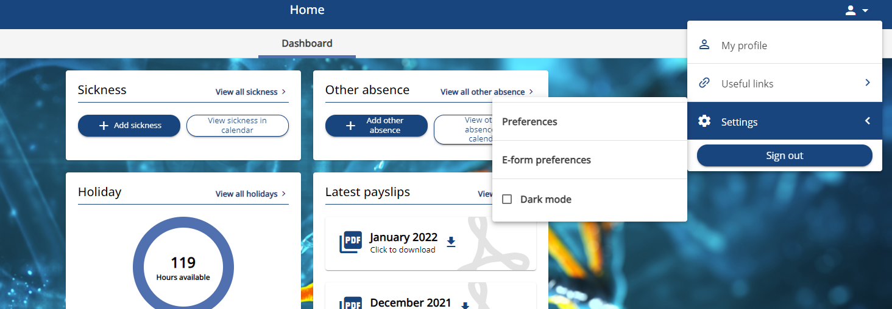

The following screen will appear
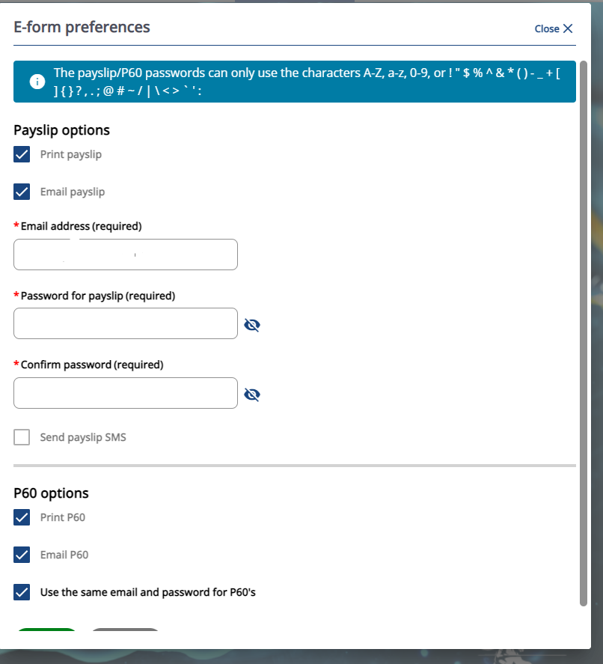

Tick the options you require, enter the email account of your choice and create a password and click save. Please note the option for payslips via SMS is not currently active within our system.
Each month you will receive an email from payroll@sgul.ac.uk with a pdf version of your payslip attached. However you will be required to enter your password before this can be accessed.
If you do not set up for emailed payslips then this email process will not happen for you and you will need to access online and download if required.
These settings are personal to yourself which you can change at any time.

