Amazon Business - How to Guide
- Log into the Amazon Business account for St George’s and identify the product you wish to purchase and check the cost.

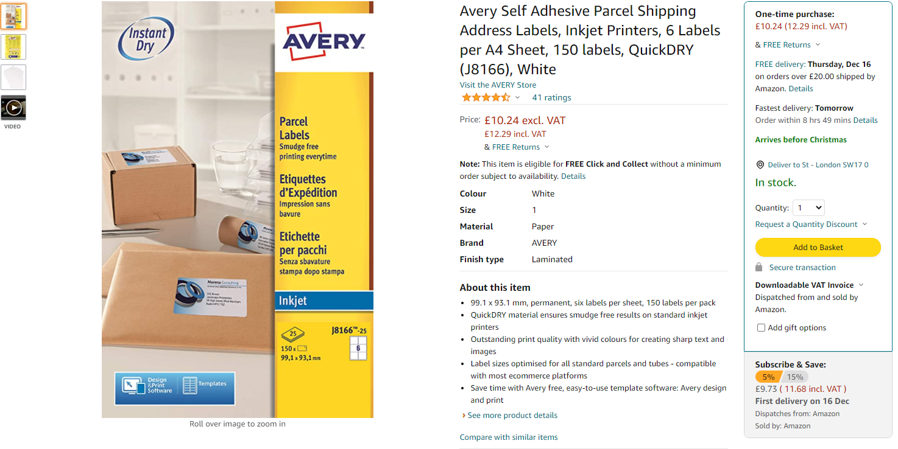
- In Agresso, raise a requisition in the normal way against the relevant budget code, using supplier “Amazon UK Services Ltd” supplier ID 107265.

- Once the purchase order has been approved by the budget holder add the product in Amazon to your basket.

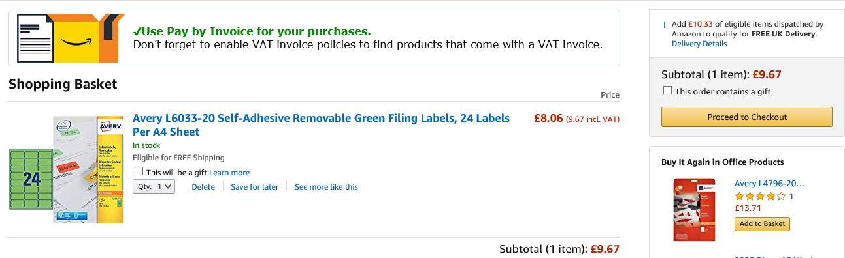

- Where possible try and order as many items together to ensure free shipping and to be as sustainable as possible.

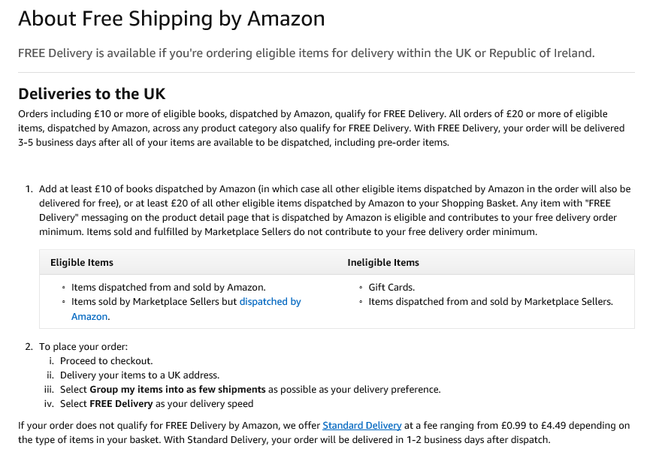

- Make your purchase in Amazon, inputting the purchase order number at the relevant stage of the purchase.

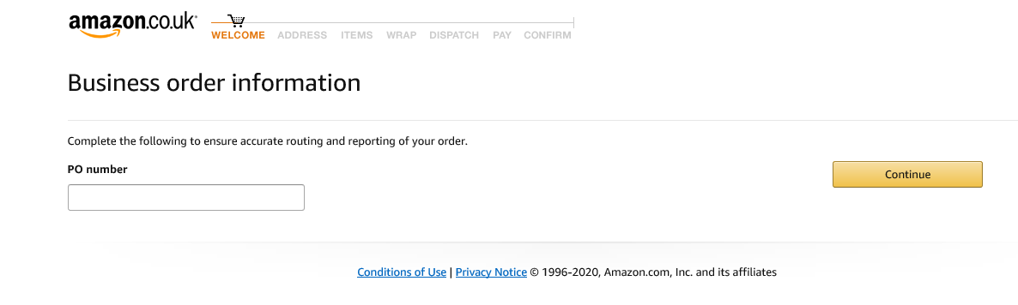

- Please ensure that the delivery address is correct at this stage and matches that on the purchase order.

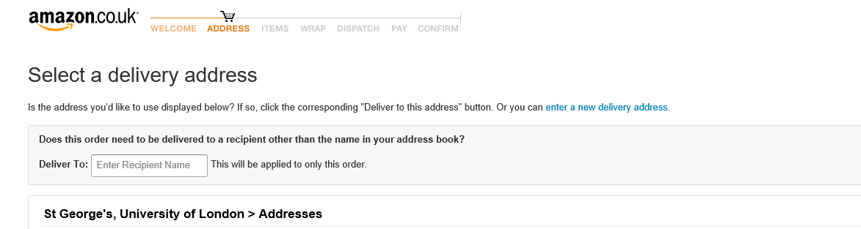

- Then select your delivery options, aiming for the cheapest or free delivery where possible.

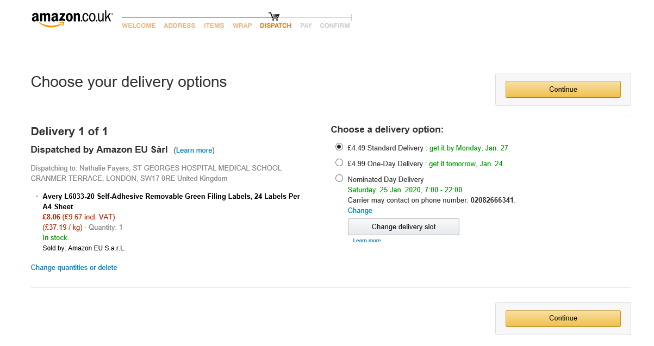

- Then ensure pay by invoice is selected.

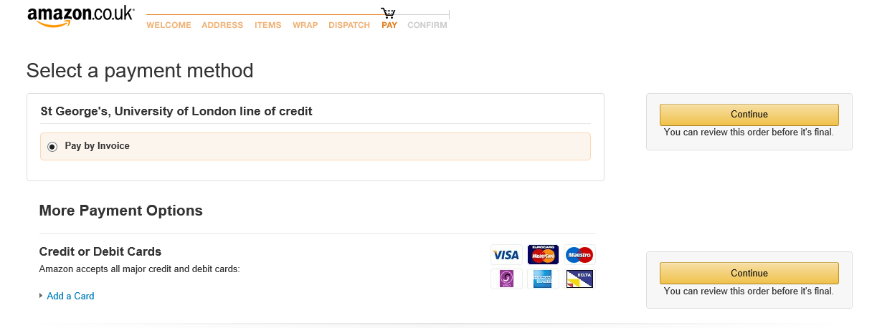

- You then have a chance to review your order before buying.

