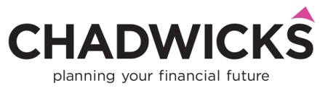

**Pensions and Tax Advisory Service**

We are pleased to offer our Pensions and Tax Advisory Service following our appointment to the panel of adviser firms providing this service for the London Pension Consortium (LPC), including Imperial College.

The Service will be of interest to those Imperial College staff members who require advice on issues around the Pensions Lifetime Allowance and Annual Allowance.

Recent reductions in both these allowances can have adverse tax consequences for many pension scheme members. This issue is of particular relevance to those earning £75K per annum or more. Our advisory service will help you to be informed about your own position in relation to these Allowances and consider your options in securing your optimum retirement income.

Chadwicks IFA are experienced in this work, having provided this specialist area of advice to the staff of eight Universities over the last three years.

We are a Chartered Firm of Independent Financial Advisers and our advisers who deliver the service are all Fellows of the Personal Financial Society (FPFS).

**To engage with the service please contact our office manager, Clair Lythe on 01244 317111 or email her at** [**clair@chadwicksifa.com**](mailto:clair@chadwicksifa.com)**.**

**Please state your name and the University you are calling from and Clair will pass your details on to one of our experienced advisers.**

The adviser will make contact with you promptly and ask about the nature of your enquiry. Should a meeting be appropriate, this can be held at your office in London or at our meeting rooms in London.

Should it be agreed you require formal advice on your pension position and options, this will always be provided in writing for your consideration.

**The cost of our service**

**Please note that an initial telephone conversation or face-to-face meeting lasting for up to one hour is free of charge and without obligation.** Should we agree to undertake any chargeable work on your behalf, a time based fee will apply. Our fee rate has been discounted for LPC staff members. We will agree our fee with you in advance of any chargeable work taking place.

We look forward to working with you.

John Chadwick

Managing Director

Chadwicks IFA